Update Base Images:
- Detect if image needs to be updated (older than 30 days - update)
  - az acr repository list --name acxcr --output table
- Now you have a list of images to update
- Triggering workflows in all github registries
Process for AKS to run a pod

- GitHub - Build Action ** microservice repo
  - Triggered by PR Merge
- Build Action/Workflows - Builds image that goes into the ACR
- Tag from ACR - Acx-Kubernetes-app
  - A manual update to the repo, a PR, and a Merge to get done
  - This is the control that Rewald loves, he can roll back by having a PR ready with old tag values, quickly undo a bad deployment.
- Merge Charts - ArgoCD
- ArgoCD Detects the change, Syncs
- New image scheduled to run on pods

- Make change at MicroService Repo Code Level
- PR, Merge, Build
- New image ready in ACR
- Make change at Acx-Kubernetes-app (this controls what image from the ACR that ArgoCD Uses)
- PR, Merge, Build
- Now ArgoCD sees the new tag, new image, and schedules new image for all workloads.

- Discovery: find services/images that are ≥30 days old (or whatever threshold).
- Rebuild: rebuild each image from its current FROM base with --pull so fresh layers are used (no code change required).
- Scan: run Trivy/Grype; generate SBOM + CVE report.
- Publish: push the rebuilt image to ACR with a clear tag and capture the immutable digest.
- Visibility: produce a weekly report/PR comment listing what was refreshed, what’s stale, and CVE deltas.
- (Optional, recommended) Open a PR in the Kubernetes repo to update the image reference (tag or digest).
We do not auto-merge.

What stays manual (the last 5%)
- Review & merge the PR in the Kubernetes repo (dev/stage/prod as your flow dictates).
- Promotion decisions (when to ship to prod, canary, rollback).

- Don’t add a throwaway line in 100 Dockerfiles.
That “newline/comment to trigger a build” was a stopgap. We can trigger builds on a schedule via GitHub Actions—no code edits needed in each repo.
- You don’t need to touch every microservice repo manually.
Use one of these:
  - A reusable GitHub Actions workflow each service calls on a schedule, or
  - A central orchestrator repo that iterates over the 100 repos (via repository_dispatch) to run their existing build workflows.
- Scope clarity: base vs. service images.
  - If you have internal base images (shared parents), rebuild those first (weekly, --pull --no-cache), then rebuild services.
  - If services FROM public bases directly, the scheduled rebuild with --pull is enough to pick up fresh layers.
- Prefer digests in Kubernetes manifests.
You can stick with tags for now (that’s how it is today), but the safer end-state is:

- reproduced the current build image process in fileo peration service
- tried multiple workflows (manual rebuild, sandbox build) but no code build wouldnt work if not on master, only on push
- created new repo (sandbox) with 'dispatch' workflow that runs on button and can get called by github api (gh workflow run)
- can see the new images in the acxcr
- created simple bash script to call the dispathcer

Look into multiple brqanches

Requirement | Status today | What’s missing / Next step
Detect the current image age | Yes | Add an age filter before dispatching (script below).
Repeat through all microservices | ✅ dispatch_all.sh with repos.txt | Keep an allowlist; later add labels to skip special services.
Run CI/CD workflow to generate fresh images to ACR | ✅ Done | Add Trivy scan + summary (warn-only) to dispatcher for visibility.
Build PR for K8 App (devops repo) | Yes | Add a “PR bump” step after successful builds (outlined below).
Cap # of microservices per PR | ❌ Not yet | Batch updates: group N services per PR (configurable).
Rollback PR | ❌ Not yet | Auto-generate a “revert to previous tag” PR alongside each batch.

5 options on tagging

Option 1 - same tag, rebuilt image
No code changes -> new image with same tag
Devops repo doesnt change, argo sees no difference, pods keep running on old image
Code changes -> new image with new tag

Option 2 - new unique tag every build
Option 2 A - branch + synthetic ID
Looks like : dev-a4c115
Every dispatcher run - new unique tag even with no code change
Pros:
Works with no code changes and no empty commits
Always gives new tag for gitops + prs + rollouts
Tag format looks the same as everywhere else
Cons:
Tags itself doesnt tell you which commit it came from
Need to rely on labels / build metadata to see commit SHA
Essenially commit info living outside the tag
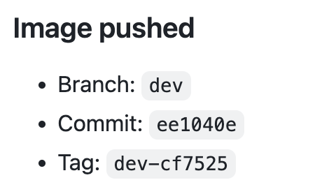

Option 2 B - branch + real SHA + version
Looks like: dev-a4c115-v2
Pros:
Tag still encodes actual commit SHA
fresh , unique tags per build with no code changes
Easily readable and traceable
Cons:
Slightly longer tags and different from rest

Option 3 - force new real SHA with empty commits
Empty commit -> HEAD moves -> real SHA changes -> new unique tag every time
Cons:
Code change
Adds noise to git history
Needs write rights + prs for commits -> more complex
PR world loses control

Option 4 - (long term) use digests in k8s instead of tags
Pros:
Digest = actual content hash -> maximum correctness
Tag names become an implementation detail
Clean git history
Cons:
More overhead and wiring, people must use digests instead of tags

“We have a few choices for how tags work in the Image Updater:
- Keep tags tied 1:1 to commits (current behavior) – easy, but doesn’t actually roll new base images into AKS.
- Always create a new tag per build:
  - 2A: branch + build ID — simple, but tag doesn’t show the commit.
  - 2B: branch + real commit SHA + rebuild number (like dev-ee1040e-r2) — gives us new tags for security rebuilds and keeps commit traceability.
- Empty commits just to change SHAs – technically works, but pollutes Git history and breaks the “no-code-change” idea.
- Long term, use digests in k8s instead of tags – very clean, but more change for the team.

For a first iteration, I’d recommend Option 2B:
- We always get a new tag for each refresh, even with no code change.
- The tag still includes the real commit SHA.
- We can then open PRs to bump r1 → r2 in the DevOps repo, and Argo will roll out updated base images in a controlled, auditable way.”

Mapping GitHub repos to ACR repos.

Will need a json file like this at some point:

- repo: Authenticx/FileOperationService
acr_repo_dev: fileoperationdiscoveryservice
acr_repo_master: fileoperationdiscoveryservice
k8s_values_path: charts/file-op/values.dev.yaml
k8s_values_key: services.fileOp.image.tag
- repo: Authenticx/AnotherService
acr_repo_dev: anotherservice
k8s_values_path: charts/another/values.dev.yaml
k8s_values_key: services.another.image.tag

Create images to testclusteracr
Instead of acxcr

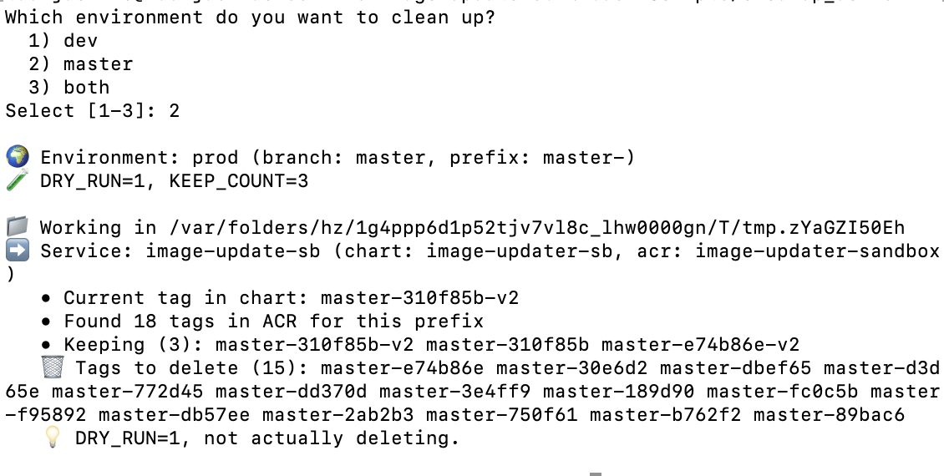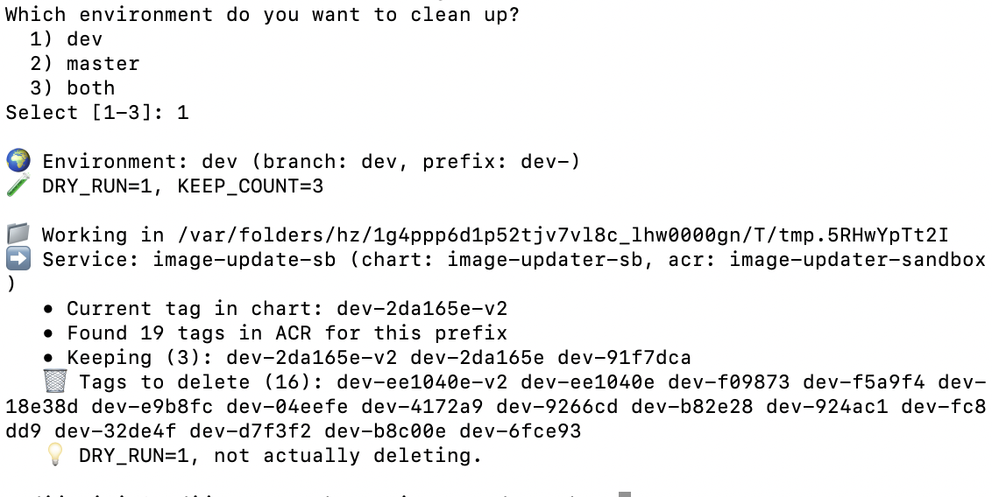

    - For different acr repos, naming isn’t consistent
  - Main, master, prod
  - Stage, staging, dev (dev-api-service vs dev-api-interop)…
Solution: could have an if one of these
For image updater – just set the names in the dispatcher, should be no problem or add tag prefixes in the lookup services
beacx/image-update-sb|image-update-sb)
CHART_DIR="image-updater-sb"
ACR_REPO="image-updater-sandbox"
DEV_PREFIXES=( "dev-" )
PROD_PREFIXES=( "master-" )
;;
For image cleaner – use the same look up service

    - Deleting branches after merging refresh PR
  - Could set auto delete on (probably risky and not needed)
  - Could just click ‘delete branch’ in the UI every time
  - No code solution here

Look up service

Bill of work producer vs bill of work

